**Unit 2 | Assignment - The VBA of Wall Street**

Kristi Herman

**2016**

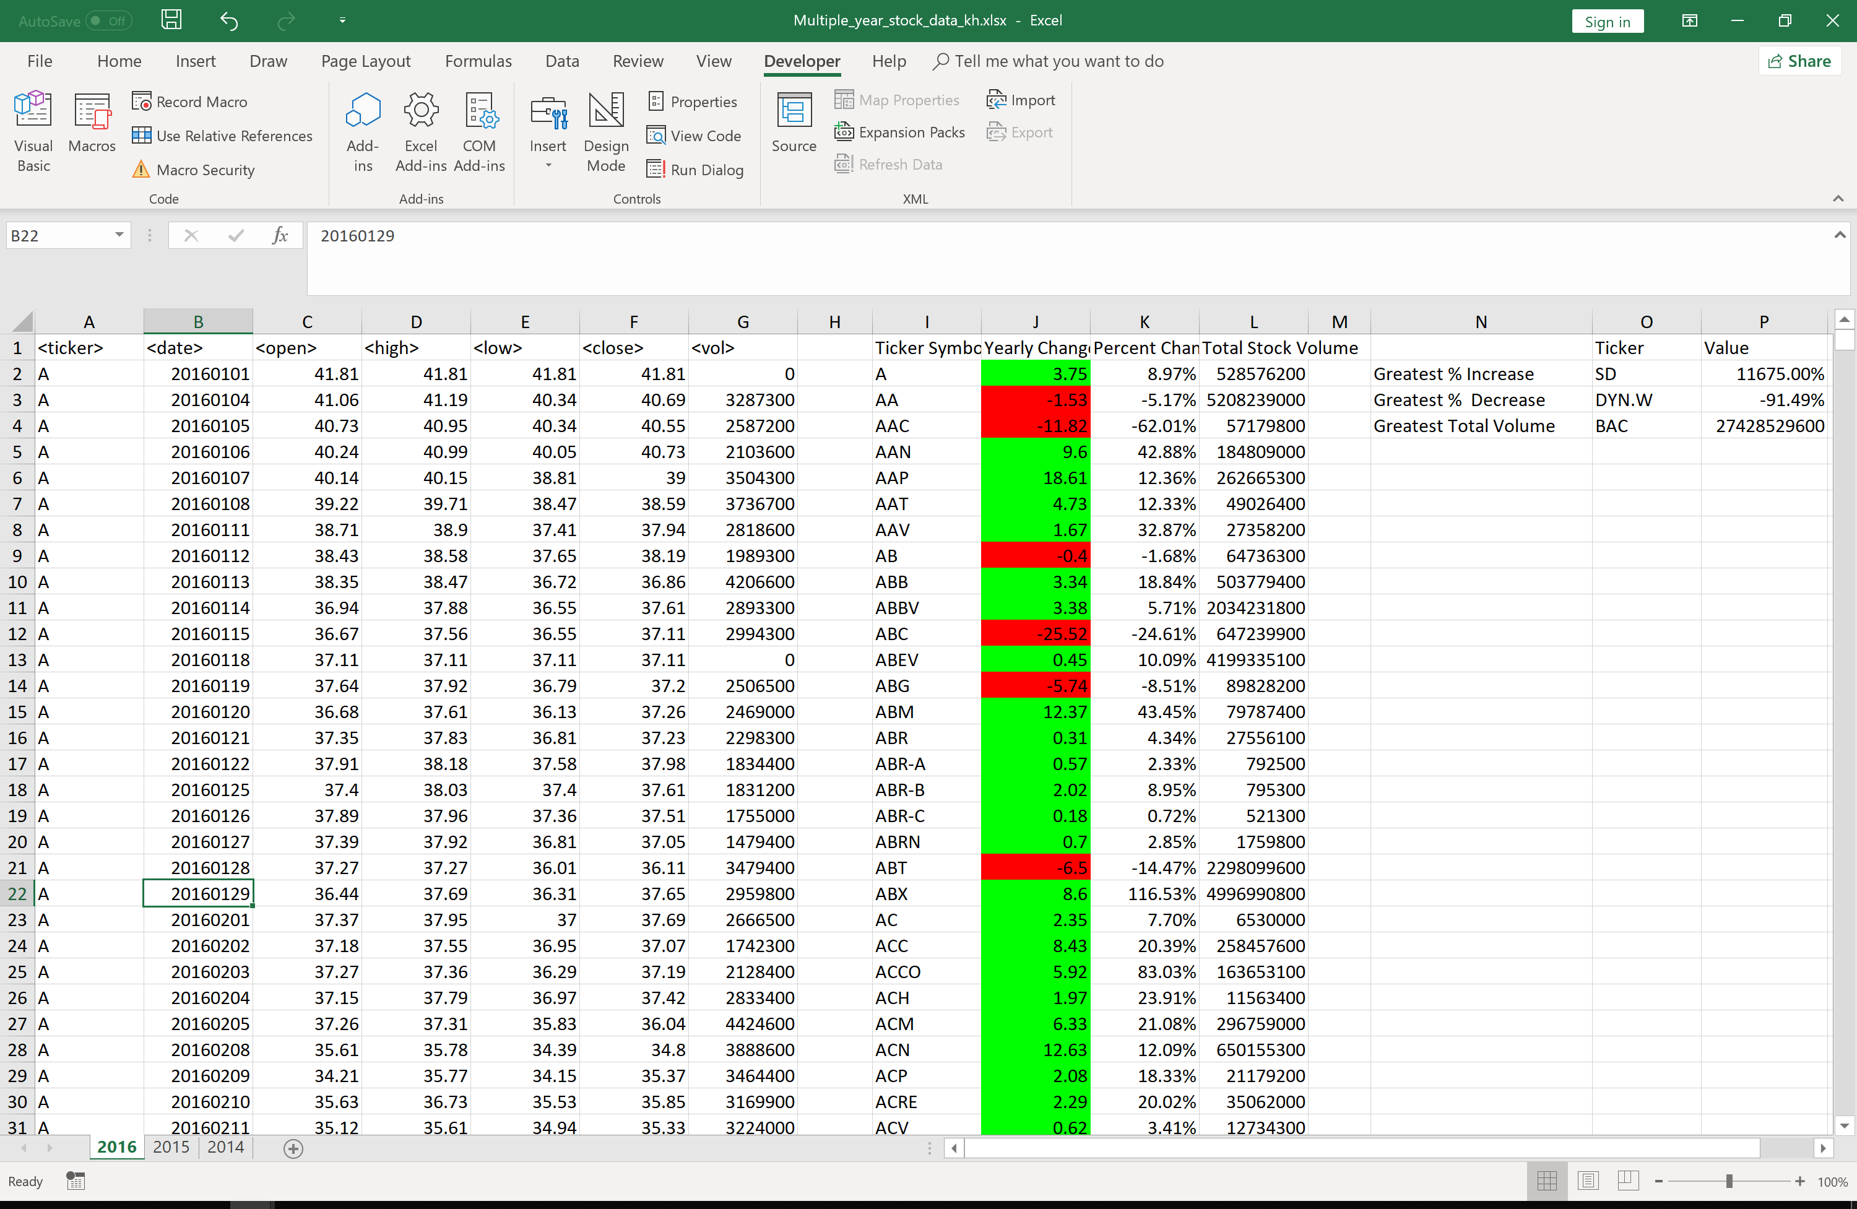

**2015**

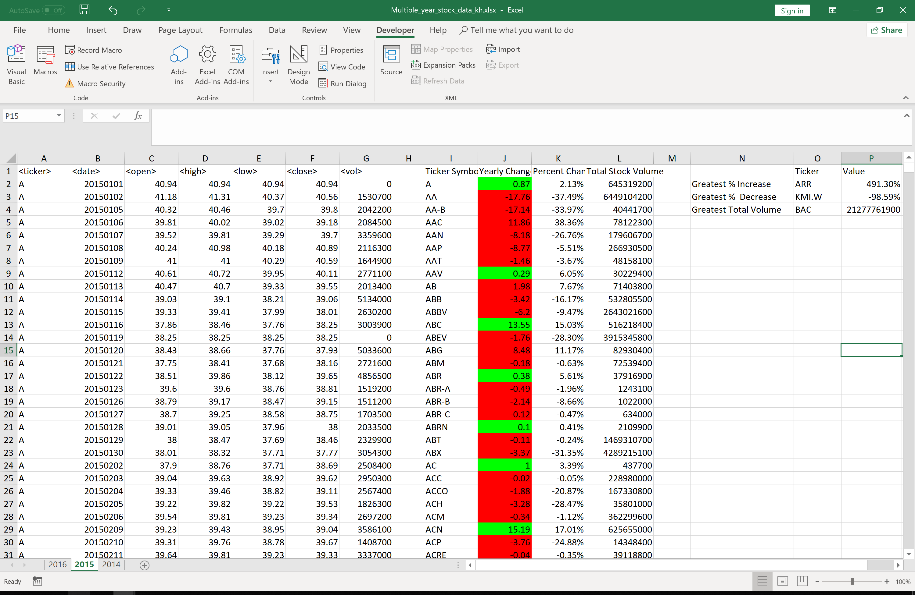

**2014**